Jung Suk Lee

JL5241

HW3 Submission

4/19/2019

# Problem 1.a

**First 20 Iterations for k=2..5**

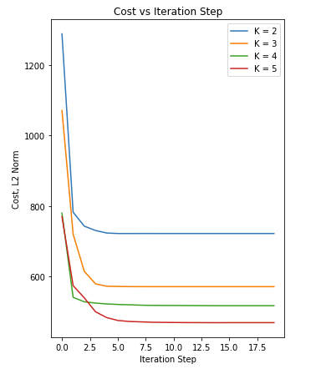

# Problem 1.b

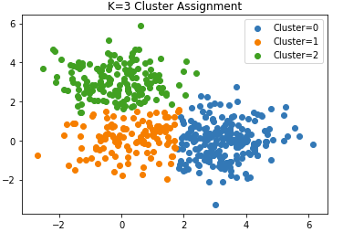

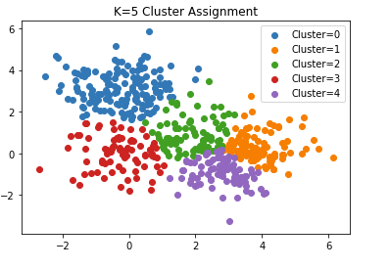

# Problem 2.a

**EM Algorithm Objective Function Plots**

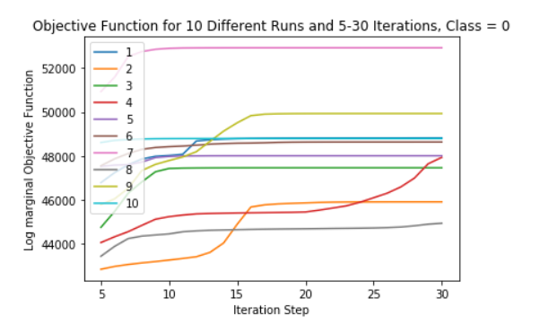

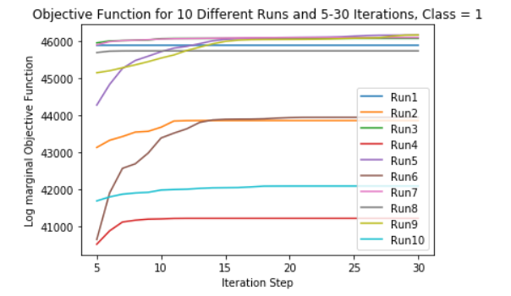

# Problem 2.b

**Confusion Matrix and Accuracy Using the Best Outputs from EM**

|  |  |  |
| --- | --- | --- |
|  | Actual =0 | Actual = 1 |
| Prediction = 0 | 194 | 7 |
| Prediction = 1 | 84 | 175 |

Accuracy = 80.21%

# 

**Repeat for k= 1..4 Accuracies nearby each other. Details and confusion matrix below**

K=1 : 77.4%

K=2 : 80%

K=3 : = 81.5%

K=4 : = 82.6%

**Confusion matrix and details**

**K = 1**

|  |  |  |
| --- | --- | --- |
|  | Actual =0 | Actual = 1 |
| Prediction = 0 | 183 | 9 |
| Prediction = 1 | 95 | 173 |

Accuracy = 77.4%

**K = 2**

|  |  |  |
| --- | --- | --- |
|  | Actual =0 | Actual = 1 |
| Prediction = 0 | 192 | 6 |
| Prediction = 1 | 86 | 176 |

Accuracy = 80%

**K = 3**

|  |  |  |
| --- | --- | --- |
|  | Actual =0 | Actual = 1 |
| Prediction = 0 | 205 | 12 |
| Prediction = 1 | 73 | 170 |

Accuracy = 81.5%

**K = 4**

|  |  |  |
| --- | --- | --- |
|  | Actual =0 | Actual = 1 |
| Prediction = 0 | 210 | 12 |
| Prediction = 1 | 68 | 170 |

Accuracy = 82.6%

# Problem 3.a

**Joint log likelihood of Iterations 2 to 100 for 10 different runs**

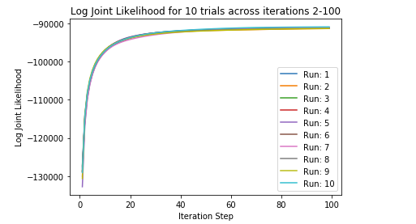

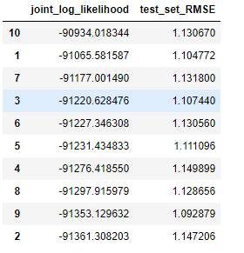

Trial 10 has the highest final joint log likelihood but not the lowest RMSE.

# Problem 3.b

Below are lists of Starwars, my fair lady, and good fellas movies in their respective orders and their 10 closest movies and its distances sorted by closest movies.

**TWO COLUMNS(MOVIES AND DISTANCES) EACH IN FOLLOWING ORDER AND SORTED BY CLOSEST MOVIES:**

**STAR WARS, MY FAIR LADY, GOOD FELLAS**

